# Lesson 3 Algorithms in computing

## Learning objectives

1. Design algorithms for mathematical computing tasks using
   1. formulas
   2. conditional structures (if –statements)
   3. loops
2. Develop analytical skills that will be needed in later units when we learn computer programming.

## Agenda

1. Nested decision structures – 5 min
2. Algorithms used in technology – 10 min
   1. Phone roaming
3. Writing mathematical algorithms – 20 min
   1. Find the GCD of two numbers

## Nested decision structures

**Task 3** Predict the color of water when colors are added

|  |  |
| --- | --- |
| **Input**: Number of drops of red and blue dye dropped into water | **Output**: The resulting color printed on screen |
| **Algorithm**:  Let R = # red drops  Let B = # blue drops  If R > 0:  If B > 0:  Output “The water is purple”  Else: (*that is, if B = 0)*  Output “The water is red”  Else: (*that is, if R = 0)*  If B > 0:  Output “The water is blue”  Else:  Output “The water is clear” | |

### Algorithms used in technology

Example 1: Phone roaming

How does your cell provider know if you’ve crossed the American border?

Your phone is in constant, silent communication with nearby cell towers.

* The towers send signals to your phone every few minutes
* Your phone sends signals back
* The tower measures the time that elapsed between the signals.
* From this it can determine _________? (Ans. Your distance from the tower!)

Suppose Tower 1 is 50 km from the US border. By sending and receiving silent signals to your phone, the tower determines you are 70 km from the tower.

Does that mean you’re in the U.S.? (No.)

What do you think is needed to pinpoint your location exactly? (Two more towers!)

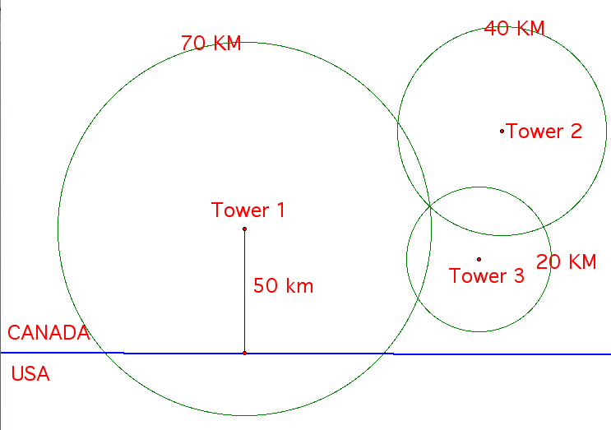

Tower 2 senses that you are 40 km from it, and Tower 3 senses that you are 20 km from it. You are at the intersection of the three circles with radius, 70, 40 and 20.

Where are the algorithms here?

The software in the tower computers contain algorithms that:

* calculate their distances to nearby phones
* communicate those distance to other towers
* can find the intersection of 3 circles, and determine if that intersection point is within Canada.

## Writing mathematical algorithms

Example 1: Finding the GCD of two integers

In the Grade 10 course ICS2OI, we programmed an algorithm to reduce a fraction:

|  |  |
| --- | --- |
| Input: Unreduced fraction of form n/d | Output: Reduced fraction of form n2/d2 |
| Algorithm:  If d = 0:  Output “Can’t divide by zero”  Else:  g = gcd( n, d ) *### But how do we calculate the GCD of two numbers?*  n2 = n / g  d2 = n / g  Output “The reduced fraction is ” n2 / d2 | |

Let’s explore an algorithm for finding the GCD called ***The Euclidean Algorithm***

Find GCD of 44 and 12. (The answer will be 4)

|  |  |  |
| --- | --- | --- |
| MAX | MIN | Remainder of MAX ÷ MIN |
| 44 | 12 | 8 |
| 12 | 8 | 4 |
| 8 | **4** | 0 |

Find GCD of 90 and 10. (The answer will be 10)

|  |  |  |  |
| --- | --- | --- | --- |
| MAX | MIN | Remainder of MAX ÷ MIN | |
| 90 | **10** | 0 |

Find GCD of 9 and 11 (The answer will be 1 since 9 and 11 have no common factors)

|  |  |  |  |
| --- | --- | --- | --- |
| MAX | MIN | Remainder of MAX ÷ MIN | |
| 11 | 9 | 2 |
| 9 | 2 | 1 |
| 2 | **1** | 0 |

Find GCD of 243 and 21 (*Students try this on their own)*

From those examples, we can write down the Euclidean algorithm.

|  |  |
| --- | --- |
| Input: Two positive integers a, b | Output: The GCD of a, b |
| The Euclidean Algorithm:  Let MAX = larger of a, b  Let MIN = smaller of a, b  R = MAX % MIN (*% means “remainder when divided by”)*  Repeat while R ≠ 0:  MAX = MIN  MIN = R  R = MAX % MIN  Output “The GCD is “ MIN | |